FEATURES TO ADD FOR FINANCIAL MODULE
15.07.2026
RECEITAS PART
Add Bank column to the list on Contribution Payment. Add Filter by Bank
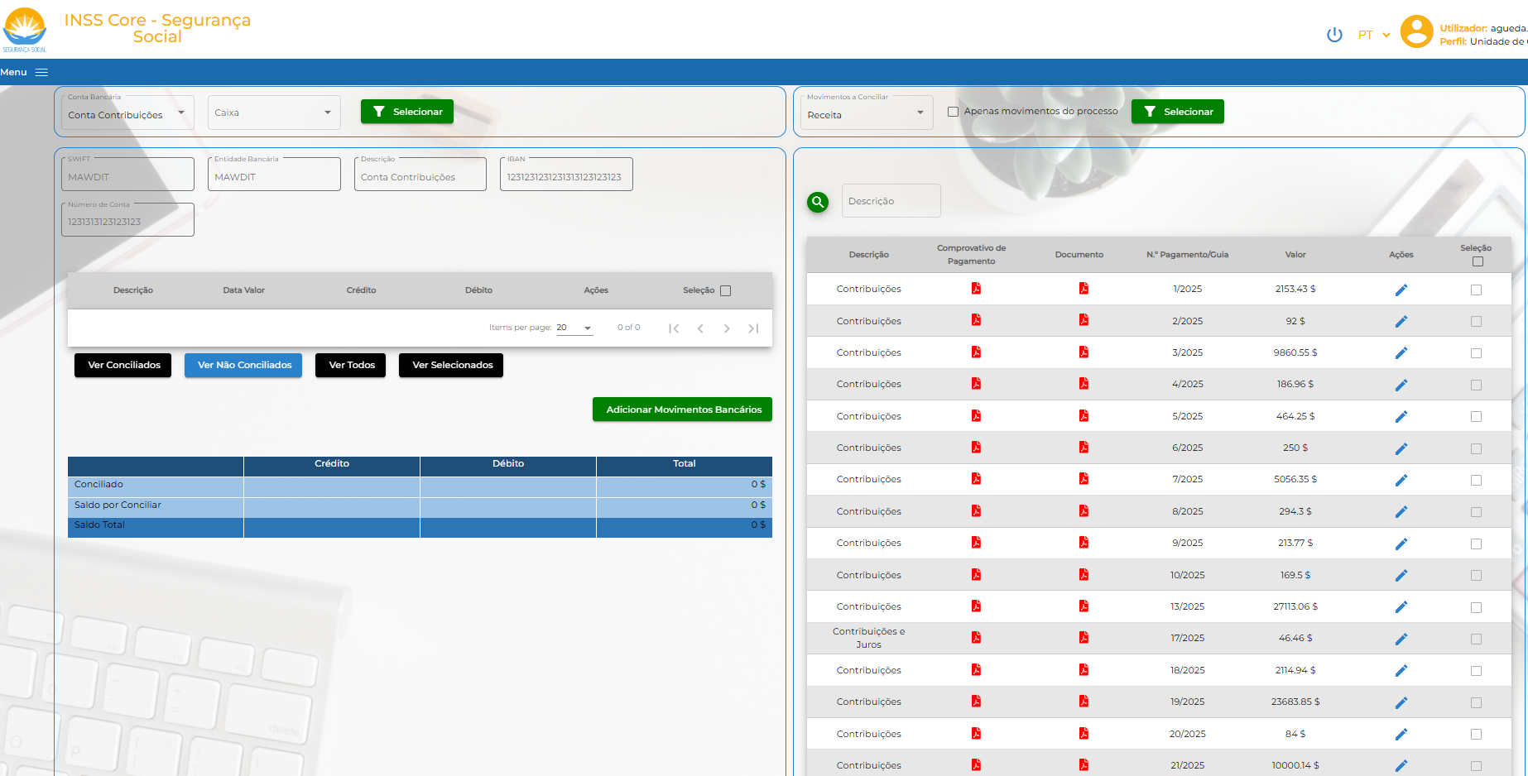
Replace current design Document (Invoice) with Invoice design generated in Contribution module
Bank

The value of this column do match to the value in Guia Pagamento/Invoice. The information on this column must synchronize
Current design Document (Invoice)
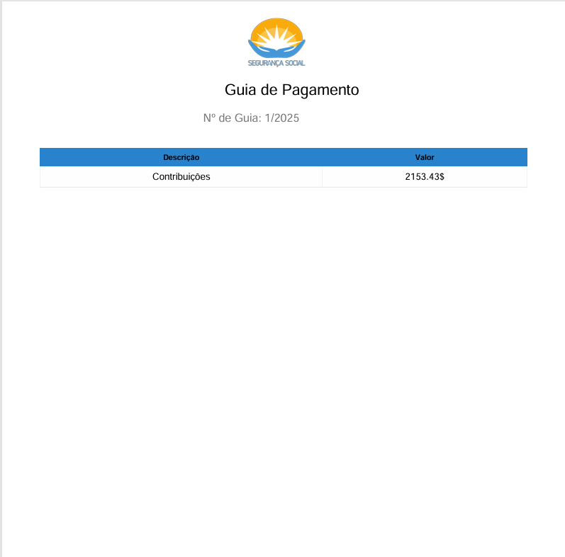

Invoice design generated in Contribution Module
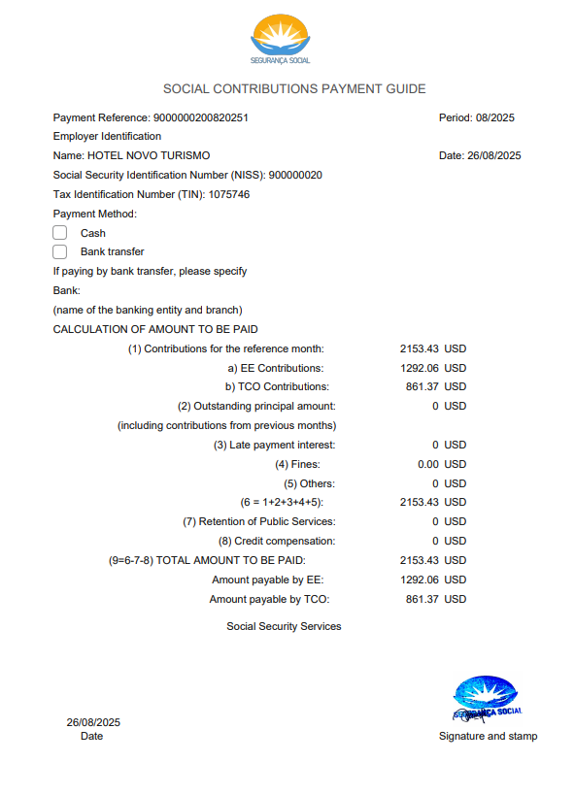

DESPESA PART
Add Bank Executar Pagamento (Need to be connect with backend for getting data as enum or the other)
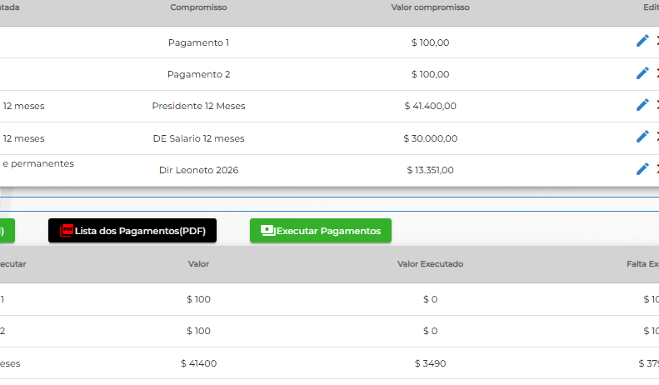
Open Executar Pagamentos
List options contained all banks in Timor-Leste

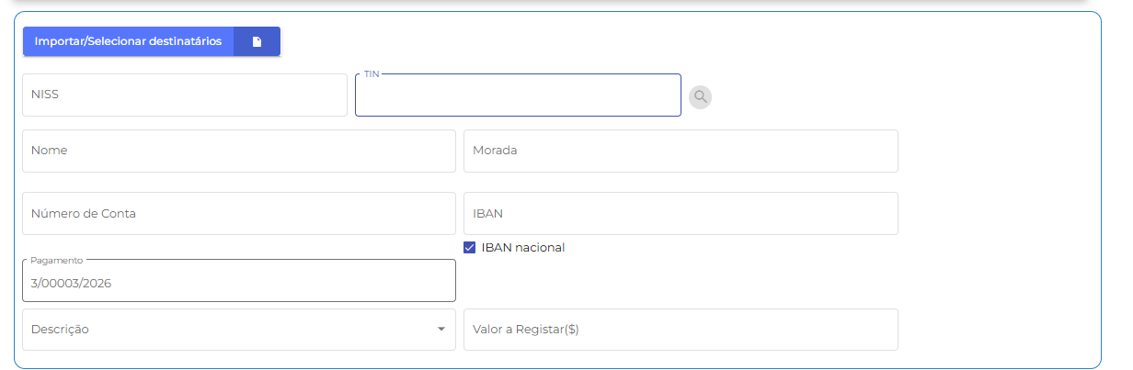

Add more chars to Description when Register Despesa
